

**Observations of hat wearing**

**behaviour in Queensland primary schools:**

**Training manual for volunteer observers**

**Authors:**

Dr Simone Harrison

Nicole Bates

Dr Jane Nikles

Denise Turner

**3rd Edition Revised April 2017**

**JCU Skin Cancer Research Unit,**

**College of Public Health, Medical & Vet Sciences,**

**Division of Tropical Health and Medicine (DTHM)**

**James Cook University**

**Background:** Queensland has extremely high levels of ambient ultraviolet radiation (UVR) and the highest rates of cutaneous melanoma (CM) and non-melanocytic skin cancer in the world. Queensland children also develop pigmented moles (the most important risk marker for CM) earlier in life and in higher numbers than children raised in temperate climates, putting them at higher lifetime risk of CM. Strategies to reduce sun-exposure (shade/hats/clothing/sunscreen) can reduce mole development and subsequent CM risk, particularly if they are introduced during the first 10 years of life. The SunSmart Schools Program which was introduced by the Cancer Council in 1998 led to significant improvements in sun-protective behaviour in schools. However, photographs published by The Sunday Mail in 2009 showed school students from as far North as Cairns, and as far south as Brisbane spending time outdoors during peak UVR times at school without a hat or access to shade. This led to concern that sun-protection practices in Queensland schools could be on the decline, and further research by our group has confirmed this hypothesis. The program we hope you will assist us with is designed to bolster hat-wearing rates in schools across Queensland and beyond.

**Aim:** We hope to observe and record the hat wearing practices of school students and their adult role-models in an unobtrusive way in as many primary schools in the Queensland region as possible. This includes public (state government) primary schools and private (non-government) primary schools (Prep to Grade 6), and combined schools (Prep to Grade 12). When sufficient data has been collected across seasons and time of day, we will collate the data and feed the information back to school management so that they can see how they are performing relative to their peer schools (their data will be ranked against de-identified results from other schools as shown in the figure below). It is important that any data you collect is not shared with anyone but the research team and treated as **CONFIDENTIAL**.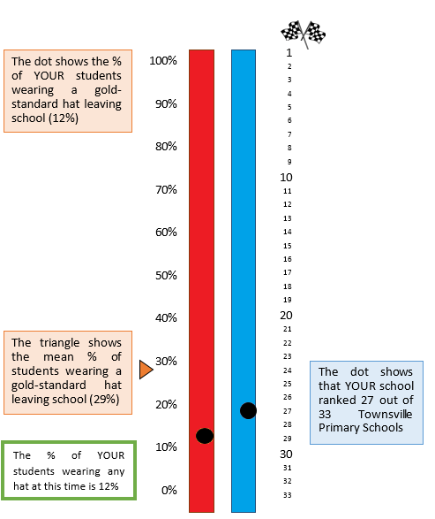

**Organising the data collection trip:** Only set out to conduct observations on a day that doesn’t look like it will rain during school hours. All observations must be conducted when it is not raining to be meaningful. Work out which schools are in a geographic area close to where you live or work or some area that you can easily access. Find out the school start time, dismissal and meal/play break times. Some of this information is included in the accompanying tables, although the information can usually be found by looking at school websites or the school prospectus online. When conducting observations in your local area, try to plan to conduct observations that include a mix of before, during and dismissal times each season, if at all possible. These observations need not be carried out on the same day. If your commitments prevent this, we welcome any observations you can conduct that fit within your schedule. When observing children arriving at school, it is important to arrive well before (at least 10 minutes before) the school bell is scheduled to ring. This provides an opportunity to observe whether the children are wearing a hat or not as they enter the school yard. It is generally sufficient to set aside around 5-10 minutes to conduct observations at each school, plus the driving time that it takes to travel between them if you plan to visit several schools in succession.

If there are two observers, the driver needs to know the order of schools to visit (e.g. which starts their lunch break soonest) to maximise the efficiency of the trip. Once you have the information about start, finish and break times, look at your street directory or Google Maps to plan the order in which you will visit the schools and ensure that the driving time between them will enable you to arrive before the break ends. When you have completed planning your trip, touch base with any fellow observers that may be accompanying you and organise a place to meet.

**Things to bring:** In order to be eligible to become a volunteer for this program, you will require a current Blue Card for suitability to work with children. These are issued by the Queensland Government Department of Justice and the Attorney-General and volunteer applications for a Blue Card are free. Details on obtaining or renewing a Blue card can be found on our website. Please ensure that you keep your Blue Card on you while conducting observations for the program.

It is important that you reinforce the message of sun-safety we are trying to promote, so make sure you consider your own sun-safety while you are out conducting observations. Please wear sun-safe clothing and a SunSmart hat while conducting these observations if you hop outside of your car. You will also need your device with the Hat-wearing app loaded (available from our website after you have completed providing your contact and Blue Card details and our brief training program). Also bring a map, clip board, pen and spare paper in case your device battery goes flat or malfunctions.

**Observation method:** Observations should be made preferably from a parked car in a public car park or from a public location on foot, such as a nature strip. It is better to try and stay in the car if viewing is easy, but if necessary you can get out of the car and try to remain inconspicuous. Please don’t go onto school property (within the school gates) or draw attention to yourself. When people are aware that observations of sun-safety are being made it is impossible to collect a true picture of their “normal” protective behaviours.

If there are two observers, observations can be made from a slow moving car by the passenger. This enables one person to collect data and another to concentrate on driving safely. The driver must always observe road rules and note school zones and the required speed limits. Working in pairs is often quicker and more efficient that conducting solo observations, but individuals get quite good at mastering observation techniques when they work alone from a suitable vantage point, particularly once they have had some practice.

Please try to make unobtrusive observations. Please do not converse with school students, caregivers or staff present about the purpose of the observations nor speak to any individual about the rationale of the observations unless absolutely necessary, as this will only alter the behaviours that we are trying to observe. If challenged, please explain that you are assisting with skin cancer prevention research being carried out by Dr Simone Harrison at the JCU Skin Cancer Research Unit and produce your Blue Card. If this doesn’t satisfy the curiosity of the enquirer, refer them to Simone Harrison by providing her contact details (mobile 0423 489 083 or email [simone.harrison@jcu.edu.au](mailto:simone.harrison@jcu.edu.au)).

Record hat wearing observations during specified school break times, such as morning tea and lunch times; before school starts and immediately after dismissal as well as during outdoor lessons such as physical education classes; and/or excursions. Include every individual observed to be on school grounds within your field of view during the observation period. School staff and caregivers present are categorised as ‘adults’ as it is not always possible to distinguish between the two. Children are classified as ‘students’ if they wear the school uniform of the school being observed.

*School hours*

Please see the tables attached for school start and finish hours as well as lunch breaks. If you notice that any times have changed, please advise the authors. Some schools have started letting students play in the first part of the specified break and then return inside to eat their food afterwards, instead of the other way around. Principals have reported that this helps the students cool down and have an opportunity for their heart rates to return to normal in order to maximise learning.

Before and After School Hours

When conducting observations before and after school, it is easiest to position your vehicle before the bell so that you are in position when the students start to leave the school exits (often near the closest paedestrian crossing to the school).

Observations can be made during the half hour prior to school commencement and a half an hour after dismissal times. Include every individual seen to enter and/or leave school grounds during the observation period that you are able to count with certainty. Try to do your best not to count the same person twice. Classify school staff and caregivers accompanying students onto school grounds or leaving school grounds with a student as ‘adults’. Also note hats on adults (includes teachers, groundsmen, etc) and record hat wearing practices of accompanying siblings in the space provided in the recording panel of the app.

During School Hours

When conducting hat wearing observations during school hours, find a spot (preferably park) where you can observe the school yard, such as a street near the oval or play area if possible. Choose somewhere where you are able to view the children at play in the school grounds during their break times while remaining inconspicuous. Do not stay too long so as to draw attention to yourself.

You can either count students as they flow out into the playground if you are in position at the beginning of the break, or alternatively, you can begin counting when they are all out in the yard. If you are waiting for them to come out, wait till the flow of people decreases before stopping counting. If the children are already out of school, do a snapshot observation over about 5 minutes if possible. Observations are easiest if all the children are in one space. It is often worth re-positioning your vehicle to another side of the school after several minutes if there are multiple play areas that can be viewed from outside the premises. Such is often the case at larger schools.

*Recording observations*

One method is to scan your finger along a line, gradually sweeping it along a line of sight. You can count the total number of children on one hand and the ones without a hat on the other hand, using your fingers. The emphasis should be on counting hat wearing by children who are not under solid shade structures. For this reason we suggest counting hat-wearing proportions for children after they have finished eating their lunch, when they are free to leave the covered area and can play outdoors.

Count each individual (all visible children/adults/siblings) and put them into the student or adult or sibling category. If possible, allocate each individual into the ‘Sunsafe hat’, ‘other’ or ‘no hat’ group. As shown in the figures below, the SunSafe hats include (from left to right): legionnaires, bucket style, and broad brimmed hats. These hats provide the best sun protection for the forehead, cheeks, chin, and neck compared to other styles. Other hats include caps (baseball or sun visors) and bicycle helmets with a visor as these provide some sun protection but not as much as the SunSafe hats. The final category is no hat, and includes no hat, bandanna, head wraps/beanies/veils or scarves worn over the head, or helmets with no visors.

If the hat is not on the head when you count the individual (e.g. hat strung around neck and hanging down the back), they are counted as not wearing a hat. If initially the individual is without a hat but they then put it on while you are still watching them, count them as wearing a hat. Hats are part of the school uniform, so usually there is only one type of hat. It is not always easy to pick the type of hat especially from a distance and especially if there is more than one type of hat worn at the school. Note bucket hats can be tucked under to look like a cap. If worn in this manner then they should be recorded in the “other hat” category.

If there are two of you conducting observations simultaneously, decide on how you will approach the counting to divide up the area to avoid replication. Where there are numerous individual’s in one area it is generally more efficient to divide the observation area into two separate areas of responsibility (e.g. if observing children during a lunch break - one observer concentrates on counting children on the play equipment to the left of the oval and while the other observer counts children with and without hats playing out on the oval).

The next section of information explains how to fill out a paper-based equivalent of the information that is request in our custom smartphone app:

*Recording the school details (please see top half of sheet below)*

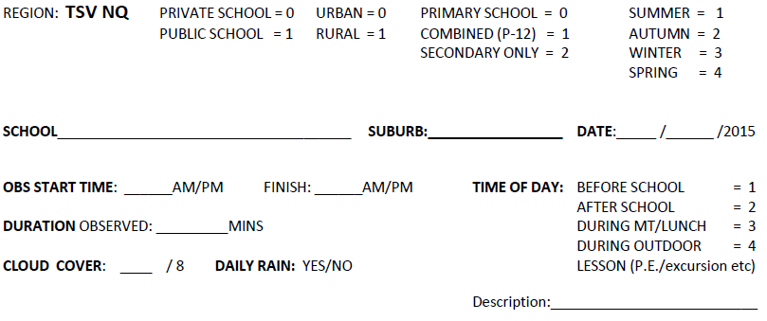

Avoid making hat-wearing observations on rainy days, however if rain develops unexpectedly during the course of an observation, please note this in the space provided on the recording sheet.

Write your own name at the top of the data recording sheet in the space provided. This will ensure that that you can be identified as the observer should any queries come to light at the time of data entry (e.g. if hand writing if difficult to interpret).

Please fill out each section of the observation sheet. The top half of the sheet is seen above. Note the date of the name of the school, the suburb and the date of the observation. Also record the precise time of day that you begin and cease observing hat wearing behaviours so that the duration of observation can be determined. Record the duration of observations in minutes lapsed. Furthermore, the season in which the observation took place should also be noted.

Note whether the school has a SunSmart sign (often on school gate/perimeter fence) or not in the comments section.

*Recording cloud cover:*

At the time of each observation, record cloud cover as a fraction of eight. For instance, a cloud free day would be recorded as 0/8th cloud cover. A sparse scattering of cloud covering approximately 1 section of a total of 8 would be recorded as 1/8. A fully clouded in overcast sky would be considered 8/8 cloud cover, while a half clouded in sky where only 50% of the field of view looking up is unclouded would be considered a 4/8th cloud cover day (see figure below).

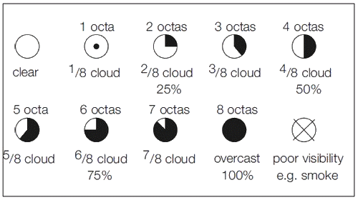

*Recording hat wearing data – bottom half of the sheet*

Please fill in the data sheets during each observation made according to the labelled sections. It may be easier to use tally marks when counting individuals, clustering in groups of five to make it easier to count at the end; or if you are counting large groups, it may be easier to write the number; or you could do a combination of these methods. At the end write down the total of each section in a circle to make it easier to read (ie total of SunSmart, other, and no hats).

This will make it easier to fill out the ‘Denom’ or denominator. The denominator is the total number of individuals (eg children with SunSmart, other, and no hats) counted in the categories of children, adult role models and siblings.

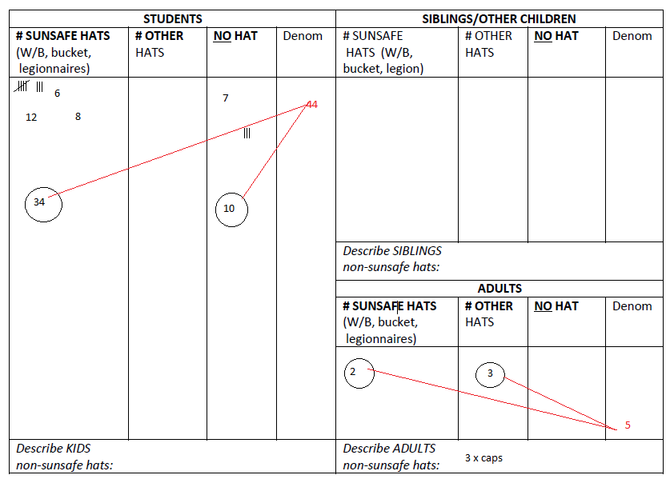

When finished, keep all the forms together in a safe place. When convenient, please scan the forms for data entry (email to Simone or Nicole) or upload the data directly into the online data entry dashboard (under development).

*Thank you very much for your assistance!*

**TOWNSVILLE SCHOOL BREAK TIMES 2015**

|  |  |  |  |  |
| --- | --- | --- | --- | --- |
| **SCHOOL** | **START** | **1st BREAK** | **2nd BREAK** | **FINISH** |
| Aitkenvale State School | 08:30 | 10:30-11:15 | 13:00-13:30 | 14:40 |
| Annandale Christian school | 08:40 | 10:30-10:50 | 12:20-13:10 | 15:00 |
| Annandale State Primary | 08:50 | 11:00-11:40 | 13:30 -14:00 | 15:00 |
| Belgian Gardens State School |  | 11:00-11:40 | 13:20-14:00 |  |
| Bohlevale State School | 08:30 | 10:30-11:00 | 12:50-13:30 | 14:30 |
| Calvary Christian College | 08:30 |  |  | 15:10 |
| Cranbrook state school | 09:00 | 11:00-11:25 | 13:10-13:45 | 15:00 |
| Currajong State School | 08:45 | 11:00-11:30 | 13:15-14:00 | 15:00 |
| Garbutt State School | 08:45 | 11:00-11:45 | 13:00-13:40 | 14:45 |
| Good Shephard Catholic Community College | 08:30 | 11:00-11:40 | 13:10-13:30 | 14:50 |
| Heatley State School | 08:40 | 11:00-11.30 | 13.20-13.35 | 15:00 |
| Hermit Park State School |  | 11:00-11:30 | 13:10-14:00 |  |
| Holy Spirit School | 08:30 | 10:30-10:50 |  | 14:50 |
| Kelso State School | 08:50 | 10:50-11:30 | 13:00-13:30 | 14:50 |
| Kirwan state school | 08:30 | 11:00-11.45 | 13.20-13.45 | 14:50 |
| Mundingburra State School | 08:55 | P-Y3: 10:30-11:15  Y4-6: 11:00-11.45 | P-Y3: 13:15-13:45  Y4-6: 13:30-14:00 | 15:00 |
| Oonoonba State School | 08:45 | 11:00-11:40 | 13:30-13:50 | 14:50 |
| Railway Estate State School | 08:55 | 11:00-11:40 | 13:15-13:45 | 15:00 |
| Rasmussen State School | 08:30 | 10:30-11:00 | 13:15-13:35 | 14:30 |
| Ryan Catholic College |  |  |  |  |
| Southern Cross Primary | 08:30 | 10:30-11:00 | 12:40-13:10 | 14:50 |
| St Anthony's Catholic College |  |  |  |  |
| St Clare's Catholic School | 08:25 | 10:30-11:00 | 13:00-13:30 | 14:45 |
| St Joseph's Mundingburra | 08:30 | 10:30-10:50 | 12:50-13:30 | 14:50 |
| St Joseph's North ward | 08:30 | 10:30-11:00 | 13:00-13:30 | 14:50 |
| The Cathedral School |  |  |  |  |
| The Marian School | 08:25 | 10:30-10:50 | 12:30-13:10 | 14:50 |
| Townsville Central State School |  | 10:20-11:00 | 13:00-13:40 |  |
| Townsville Grammar Junior School (p - 6) |  |  |  |  |
| Townsville South State School | 08:45 | 11:00-11:45 | 13:15-13:45 | 15:00 |
| Townsville West State School | 08:55 | 10:45-11:15 | 13:00-13:15 | 15:00 |
| Vincent State School |  | 11:00-11:45 | 13:15-13:45 |  |
| Weir State School | 08:45 | 10:45-11:30 | 13:00-13:30 | 14:45 |
| Willows state school | 09:00 | 11:00-11:40 | 13:10-13:50 | 15:00 |
| Wulguru State School | 08:55 | 10:55-11:40 | 13:15-13:45 | 15:00 |

# Appendix B: Swimming carnival hat and shirt wearing observation manual



**Observations of hat and shirt wearing**

**behaviour at Townsville interschool**

**swimming carnivals: Training manual**

**for volunteer observers**

**Author:**

Nicole Bates

**Revised October 2015**

**Skin Cancer Research Group,**

**College of Public Health, Medical & Vet Sciences,**

**Division of Tropical Health and Medicine (DTHM)**

**James Cook University**

**Background**

Queensland has extremely high levels of ambient ultraviolet radiation (UVR) and the highest rates of cutaneous melanoma (CM) and non-melanocytic skin cancer in the world. Queensland children also develop pigmented moles (the most important risk marker for CM) earlier in life and in higher numbers than children raised in temperate climates, putting them at higher lifetime risk of CM. Strategies to reduce sun-exposure (shade/hats/clothing/sunscreen) in the first decade of life can reduce mole development and subsequent CM risk. The introduction of the SunSmart Schools program in 1998 by the Cancer Council led to significant improvements in sun-protective behaviour in schools over a decade. However, photographs published by The Sunday Mail (2009) showing school students from Cairns to Brisbane who were outdoors during peak UVR times without a hat or access to shade, has led to concern that sun-protection practices in Queensland schools may be on the decline.

Swimming carnivals are normally held during school hours, which coincide with peak UVR times during the day. Children at swimming carnivals are exposed to both overhead and reflective UVR, thereby increasing their risk of sunburn.

**Aim**

Our aim is to observe hat wearing by children, and adult role models during interschool swimming carnivals in the Queensland region as possible. Schools that attend these interschool swimming carnivals include public (state government) primary schools and private (non-government) primary schools (Prep to Grade 6), and combined schools (Prep to Grade 12).

**Organising the observation trip**

First, it is important to determine the dates and locations for the interschool swimming carnivals. In Townsville, these carnivals are normally held over three days in March at either the Long Tan Memorial Pool or Aitkenvale State School Swimming Pool. Due to the number of schools in the Townsville district, schools are sorted into divisions based on promotion and relegation (A, B, C, D, E and F). These divisions are assigned to a morning or afternoon carnival over the three days. Next, familiarise yourself with the school uniforms for each school in order to make it easier to recognise up to six schools at any one carnival.

**Things to bring**

To be eligible to become a volunteer, certification is required from James Cook University and a current Blue Card for suitability to work with children.

It is important that you maintain sun safety yourself, so please wear sun protective clothing, a SunSmart hat, sunscreen and sunglasses. There is normally limited shade at the swimming carnival and you may be sitting into the sun for the duration of the swimming carnival. Also bring observation sheets, clip board, pen, spare paper and a water bottle. Wear a MPA volunteer name badge if you have one.

**Observation method**

Observations are made discretely from within the complex. You may be required to pay an entrance fee or purchase a program for the carnival (which is generally a gold coin donation). Please arrive prior to the carnival starting in order to observe students arriving at the carnival. Please note that students may enter the pool complex through the main gate or from the side entrance. Therefore, it is easiest to be seated to observe both entrances if possible.

Please try to make unobtrusive observations. Please do not converse with school students, caregivers or staff present about the purpose of the observations nor inform any individual about the rationale of the observations as this will only alter the behaviours we are trying to observe. If challenged, explain that you are assisting with a skin cancer prevention research project for Simone Harrison at the JCU Skin Cancer Research Group. If this doesn’t satisfy the curiosity of the enquirer, refer them to Simone Harrison by providing her contact details (mobile 0423 489 083 or email [simone.harrison@jcu.edu.au](mailto:simone.harrison@jcu.edu.au)).

Take hat wearing observations as the students and adult role models arrive at the swimming carnival and approximately one hour into the swimming carnival when students are settled and events are underway. Shirt wearing observations are made approximately one hour into the swimming carnival when students are settled and events are underway. Include all children and adult role models that you observe. Due to the volume of individuals, hats are classified into hats ‘present’ or ‘absent’. Shirts are also categorised into shirt ‘present’ or ‘absent’.

Only include individuals where you can clearly identify the school. For example, if the adult role models are not seated within the school zones, you may not be able to identify the school (unless they have a school shirt). For students, if the student is wearing a school uniform or school hat or are within the designated school zone, you may be confident in assigning the student to School A. However, if the student is not wearing a school uniform or school hat and was on the boundary of two school zones, they should not be included in the observation.

*Recording observations*

One method is to scan your finger along a line, gradually sweeping it along a line of sight. You can count the total number of individuals on one hand and the ones without a hat on the other hand, using your fingers.

Count each individual (all visible children/adults) and put them into the student or adult category. Allocate the individual to a hat ‘present’ or ‘absent’; and repeat to allocate individual to shirt ‘present’ or ‘absent’. If the hat is not on the head when you count them (e.g. hat strung around neck and hanging down the back), they are counted as not wearing a hat. If initially the individual is without a hat but they then put it on while you are still watching them, count them as wearing a hat.

*Recording observations on sheet*

Write your own name at the top of the data recording sheet in the space provided. This will ensure that that you can be identified as the observer should any queries come to light at the time of data entry (e.g. if hand writing if difficult to interpret).

Please fill out all of the details as they are required when entering the data. The next section of information explains how to fill out the observation sheet (as shown below):

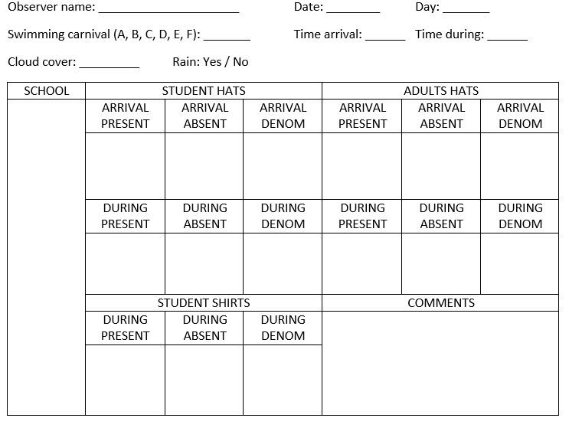

Please fill out each section of the observation sheet. The top part of the sheet includes the date, day, swimming carnival division, time the schools arrival, time during (approximately one hour into the swimming carnival), cloud cover and if it is raining.

*Recording cloud cover:*

At the time of each observation, record cloud cover as a fraction of eight. For instance, a cloud free day would be recorded as 0/8th cloud cover. A sparse scattering of cloud covering approximately 1 section of a total of 8 would be recorded as 1/8. A fully clouded in overcast sky would be considered 8/8 cloud cover, while a half clouded in sky where only 50% of the field of view looking up is unclouded would be considered a 4/8th cloud cover day (see figure below).



*Recording observations*

Please fill in the data sheets during each observation made according to the labelled sections, including the school name. It may be easier to use tally marks when counting individuals, clustering in groups of five to make it easier to count at the end; or if you are counting large groups, it may be easier to write the number; or you could do a combination of these methods. At the end write down the total of each section in a circle to make it easier to read. This will make it easier to fill out the ‘Denom’ or denominator. The denominator is the total number of individuals (eg children with hats ‘present’ and ‘absent’) counted in the categories.

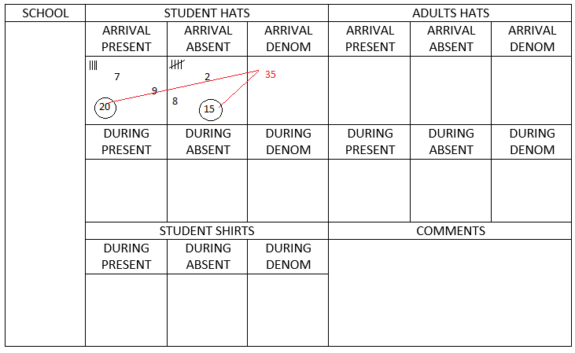

When finished, keep all the forms together in a safe place. When convenient, please scan the forms for data entry (email to Simone or Nicole) or upload the data directly into the online data entry dashboard (under development).

*Thank you very much for your assistance!*